HW8: Project – Sales Data Analysis

This project is a mini database application (Unit 4_2_ch9 struct slides)

A company has six salespeople. Every month, they go on road trips to sell the company’s product. At the end of each month, the total sales for a salesperson in that month, together with that salesperson’s ID and the month, is recorded in a file. At the end of each year, the manager of the company wants to see an annual sales report. Due to the amount of data involved, he’s like to be able to view the report by ID or by total sales.

Write a program to load id data from salesID.txt, sales data from salesData.txt (unknown # of records. The records are not in any order of sales id or month), calculate the total sales of each person in a year, and display a report. Shell code is provided in HW8_SalesReport_shell.cpp. You need understand the shell code and then add:
- ADD CODE #1: declaration of two functions sortByID and showReport. Also include:
  - Function prologue comment
  - /*IN*/, /*OUT*/, /*INOUT*/ comments to each function parameter.
  - Pre- and Post- condition comments for each function.
- ADD CODE #2: complete function loadData
- ADD CODE #3: implementation of two functions sortByID and showReport

You’re not supposed to modify the given code otherwise (at least 20% penalty).

The output of your program (data, format <left/right aligned, # of decimal digits>) must match those screenshots:
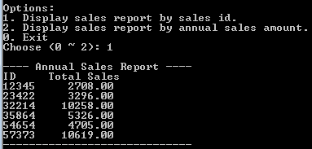

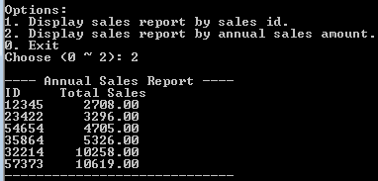

Comment your program appropriately. Pay attention to the standard stuff like coding style, indention, heading, and curly braces.

Submission: 2 files
- In one word/pdf document:
  - Screenshot(s) of execution
- One .cpp files: name it HW8_YourLastName.cpp

- Use the rubric below to check the completeness of your work before turning it in.

Rubric: CS225, HW8

Item | Max  (Pts) | Received  (Pts)
Project (18 pts)
ADD CODE #1: function declaration (plus comments): sortByID | 2
ADD CODE #1: function declaration (plus comments): showReport | 2
ADD CODE #2: function loadData  - Read all records from file  - locate a matching record from the array  - add salesAmount to totalSales of matching record | (5)  2  2  1
ADD CODE #3: function implementation: sortByID  - Loop through all records of the array  - Correctly sort one record  - Correctly sort all records | (4)  1  1  2
ADD CODE #3: function implementation: showReport  - Display a report header  - Display all records  - Total Sales data in proper format | (4)  1  2  1
Your project compiles and runs | 1
Programming style (2 pts)  - Consistent indentation: preferred 2 spaces for each level  - Meaningful names for constants and variables; Proper comments in the program | 0.5  1.5
Penalty
Modified given .cpp file in unspecified ways | At least (- 4)
Missing required screenshot(s) | (- 2)
Total: | 20

- END -

